**Portal User’s Guide**

**Register/Update Profile in Collections Portal**

You will receive an e-mail titled **Invitation to join NCDOJ Collections Portal (**like the example below) inviting you to register. Click on the **Register** link in the e-mail and you will be directed to the portal with your invitation code already filled out on a screen like the second screen below.

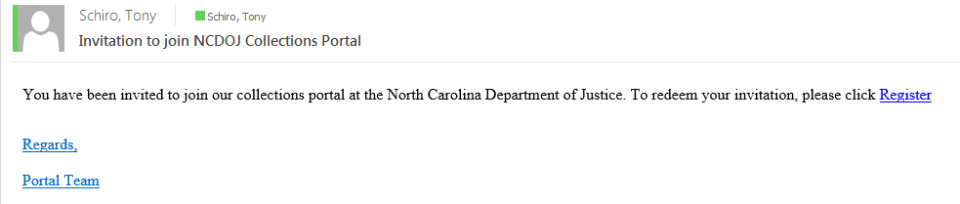

Click **Register** on this page presented to you.

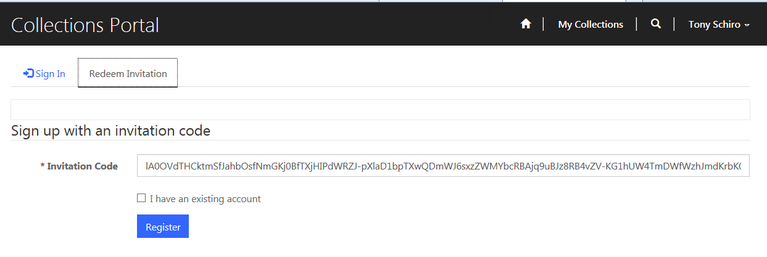

Next, you create a **Username** and **Password** for the portal, then click **Register** again.

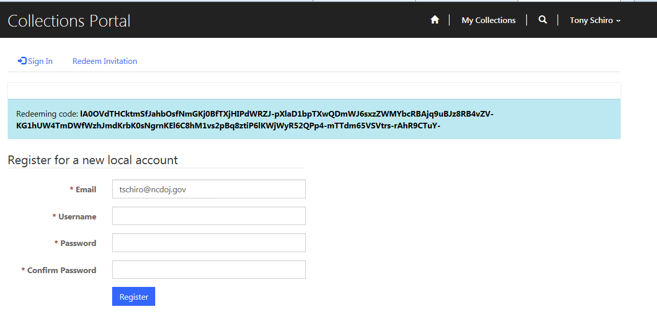

You will be presented with your profile page in the portal. All required fields have already been filled out but you have the option to change existing information or enter missing information and click **Update** at the bottom of that page.

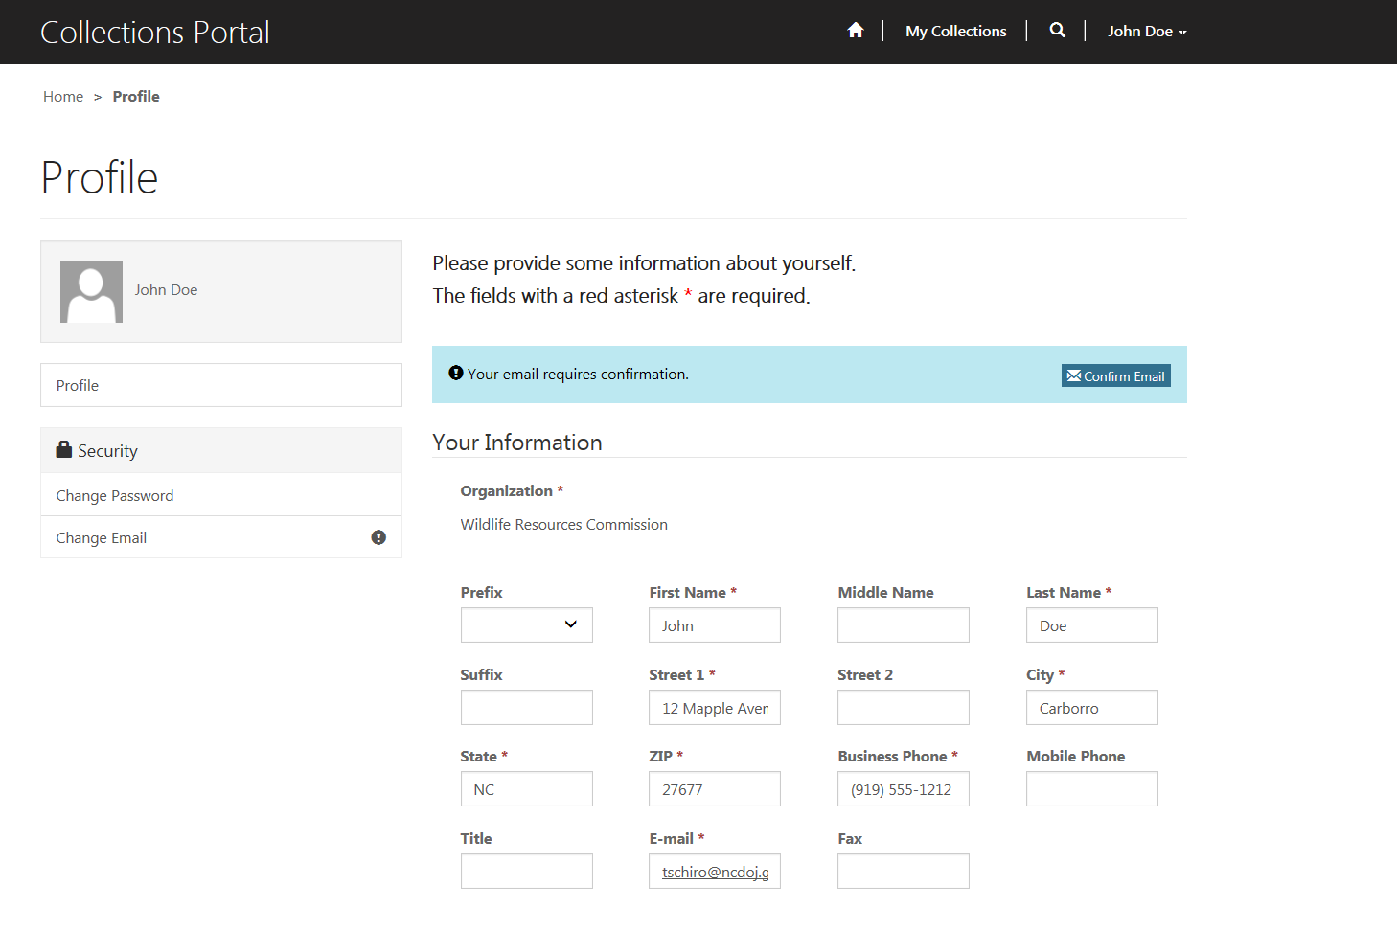

Once you are logged into the portal you can enter/update collections by first clicking on **My Collections** or click on **Collection Bulk Upload** to upload an excel file with numerous collections.

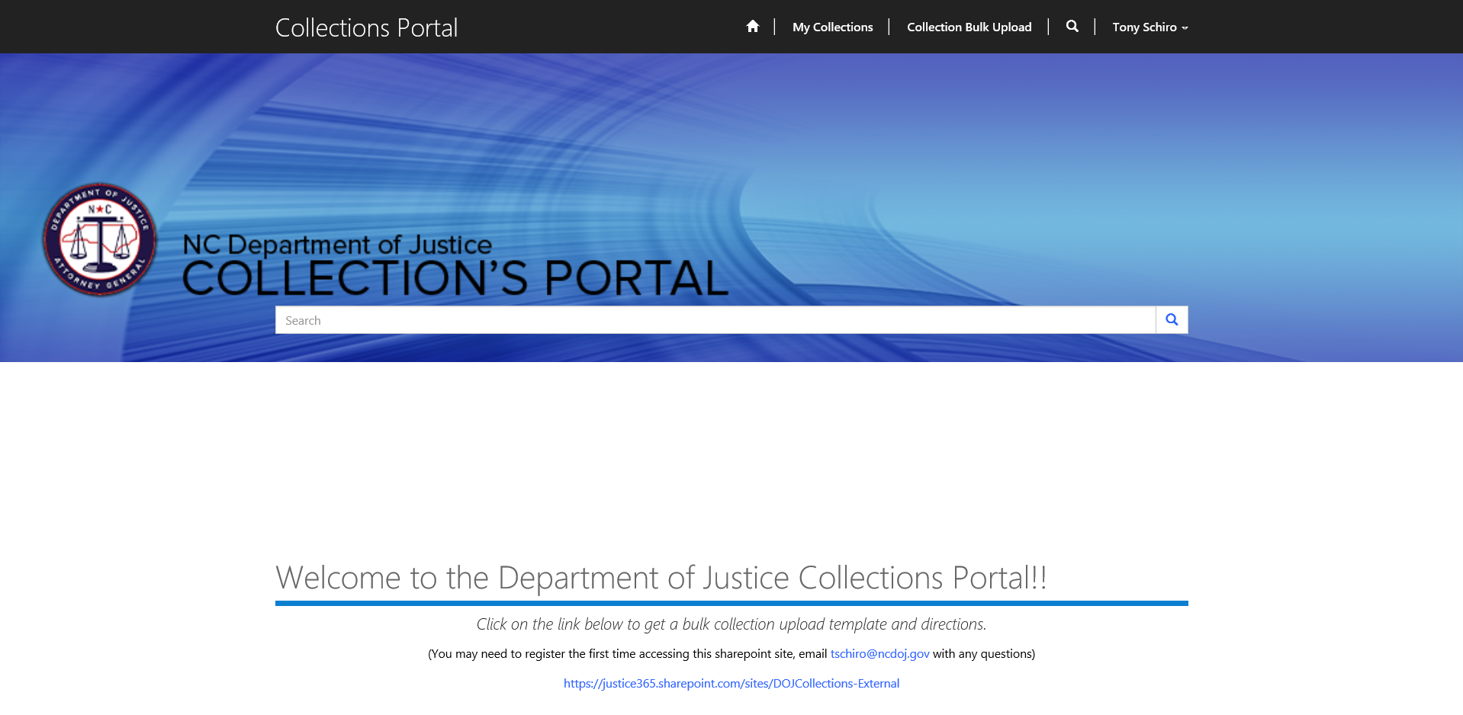

First, we will cover the process of entering/updating a single collection. Click on **My Collections** and a screen like the page below will render, click on **Create.**

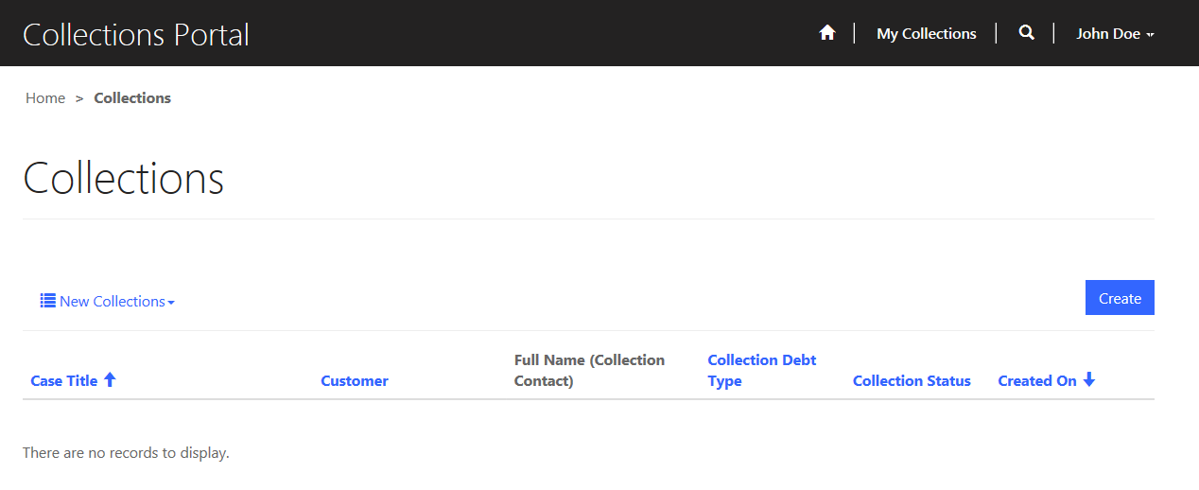

You will be directed to a page similar to the one below. The Organization and Contact will be pre-filled based on the current user’s profile. Required fields will be marked with a red *. You may fill out this collection form and if you are not ready to send it off for collection leave the check box titled **Form Complete** un-ckecked and click **Submit** in order to save the form. The collection status will remain **In Progress** until the **Form Complete** check box is checked and when the form is submitted the status will be changed to **Record Complete**.

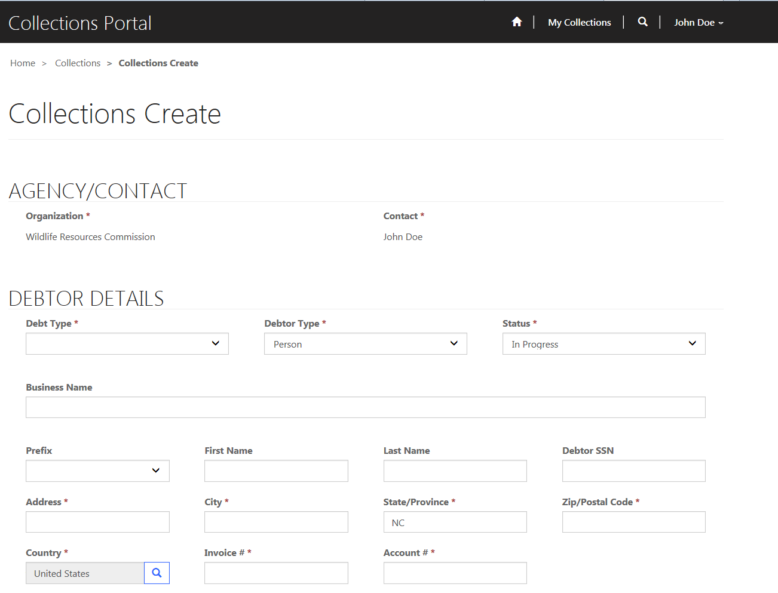

It is only after the record status is marked as **Record Complete** that the Department of Justice collections staff will begin processing the collection. If the collection staff at the Department of Justice need more information to process the request, they may reject the collection, which will trigger an e-mail like the one below and change the collections status record to **Rejected**.

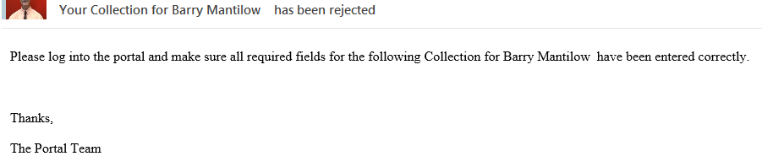

Simply; supply the additional information requested and press **Submit** again, but remember to check the **Form Complete** checkbox again. When all information needed is supplied, the collections staff at the Department of Justice will begin the collection process.

First, they will save a copy of the demand letter to the collection record. You can view/print a copy of the letter by scrolling to the bottom of the collection in the Notes section as seen below and clicking on the attachment.

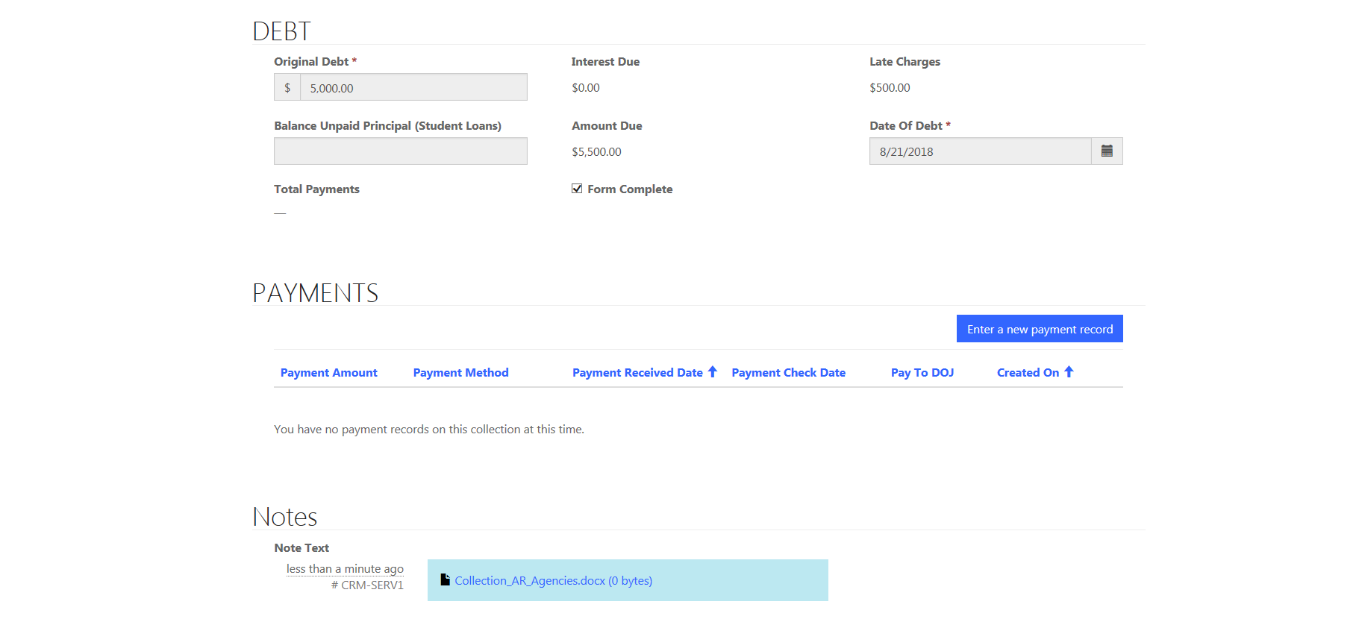

The collection staff at the Department of Justice will then proceed with printing the letter and sending it out for collection. This will change the collection record status to **Active (Letter Sent)**. If no letter response or response reason is entered by the agency after the due date passes (30 days after the letter is sent) the collection status is changed to **Due Date Passed** and the agency contact will be sent an e-mail like the one below.

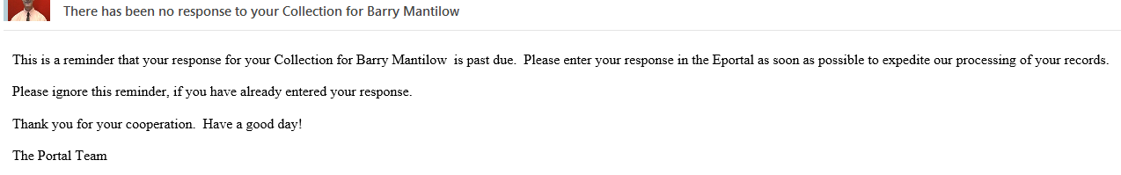

By clicking the down arrow to the right of **New Collections,** you can access views at three additional collection statuses. **Collections Needing Response** include statuses **Active (Letter Sent)** and **Due Date Passed**. **Collections With AG Recommendation** include records with the status of **AG Recommendation** (those collections the AG has made a recommendation on). **Closed Collections** are just that. All collections that have been processed and **Closed** by the collections staff at the Department of Justice.

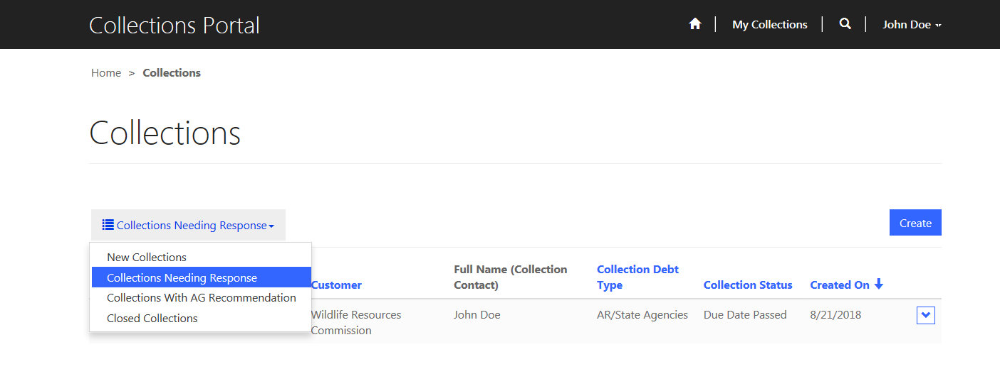

At any time after the letter is sent, a portal user can update a response and/or enter payments for the collection. To enter a collection payment click on **Enter a new payment record.**

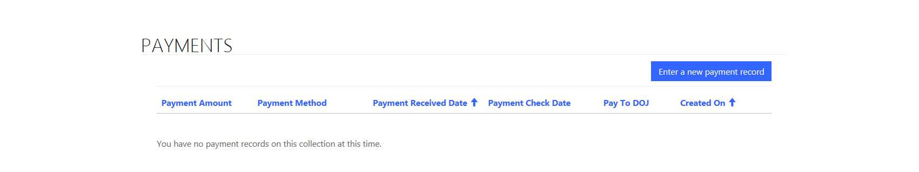

The required payment fields are marked with a red *. Click on the **Submit** button in order to save a payment record. Portal users are not authorized to update or delete a payment. If you wish to do so contact the collections staff at the Department of Justice.

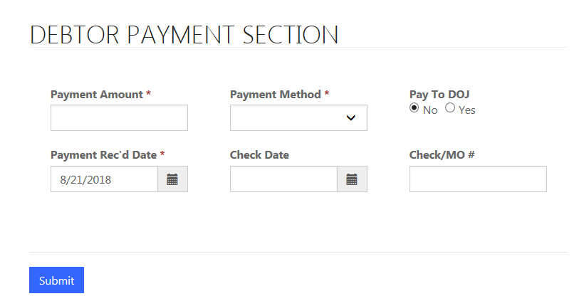

Next, we will cover the process of creating and uploading a **Collection Bulk Upload**. On the home page click on **Collection Bulk Upload**.



You will be directed to a screen similar to the one below. Click **Create**.

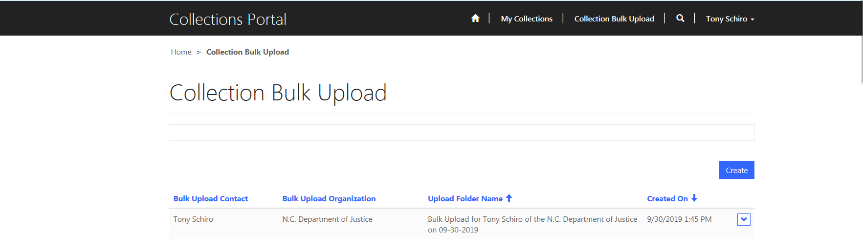

A screen like the one below will display. Default values for your organization, contact name and a folder name will automatically populate. Click **Submit**,and a folder is created on the N.C. Justice SharePoint site that you can then upload a file into. On our home page is a link to an Excel Bulk Upload Template. Modify this file’s contents and save it on your computer. The file you create and upload may contain several collections from your organization for Department of Justice to process. Please follow the Collection Bulk Upload Template Directions on the last page of this document when creating an upload file. We request that you limit the number of collections in a **Collection Bulk Upload** to no more than 100 records and one file upload per day.

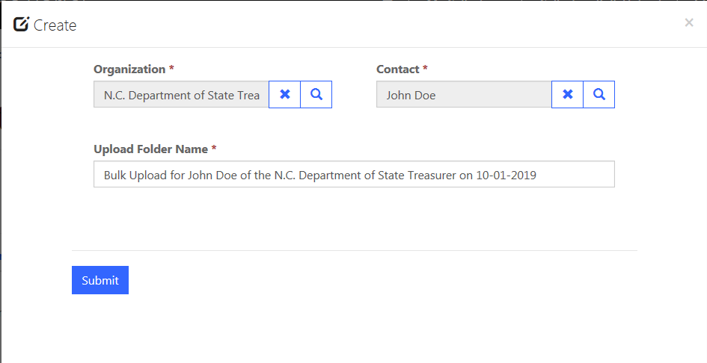

After creating the folder, click on the down arrow on the left, then click edit (see below)

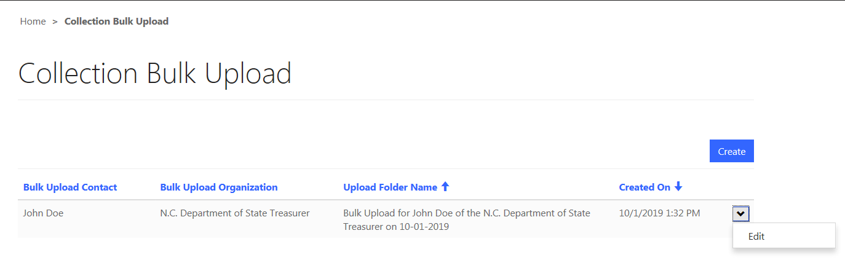

Click **Add files** and browse to the file of collection records you created. Click **Add files** on the next screen and upload this file into the SharePoint folder you created in the earlier step.

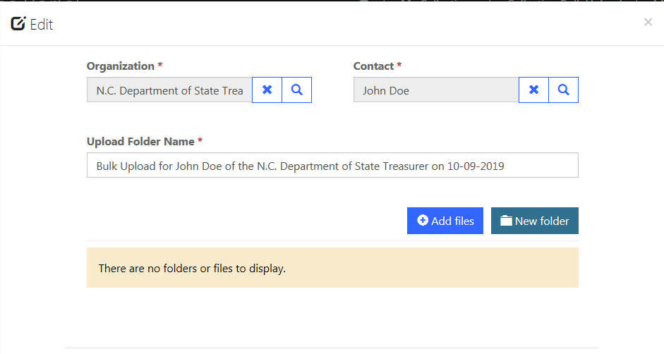

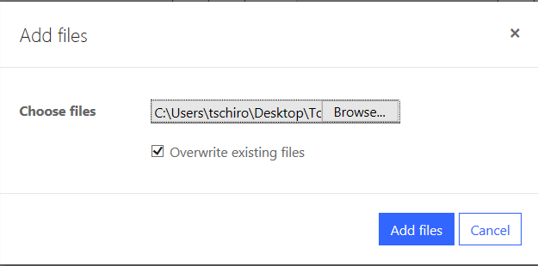

Lastly, the next screen will show the file you subsequently uploaded. Click the **X** on the top left corner to exit this screen. An email, notifying the Department of Justice Collections Department, of a new bulk collection upload created is sent at this time.

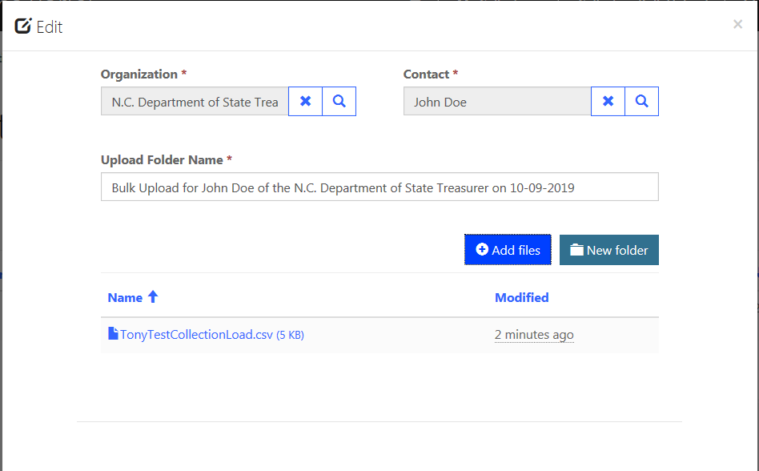

Collection Bulk Upload Template

**Column Name Requirement**

**Customer Your Organization name exactly as it appears on the portal 1**

**Debtor Type Select Person or Business from the drop down menu 1**

**Collection Contact Your collection contact full name as it appears on the portal 1**

**Collection Debt Type Select from the drop down menu 1**

**Debtor Business Name Required if debtor type is Business 2**

**Debtor Prefix Select from the drop down menu 3**

**Debtor Address Text maximum length 100 characters 1**

**Debtor Country Leave blank and it will default to the United States 1**

**Bad Address Select Yes or No from the drop down menu (default No)**

**Debtor First Name Text maximum length 100 characters 3**

**Debtor City Text maximum length 80 characters 1**

**Invoice Number Text maximum length 50 characters 8**

**Debtor Last Name Text maximum length 100 characters 3**

**Debtor State/Province Two letter state abbreviation (e.g. NC) 1**

**Debtor Account Number Text maximum length 50 characters 1**

**Debtor SSN Text maximum length 11 characters (e.g. 123-45-6789) 7, 10**

**Debtor Zip/Postal Code Text maximum length 20 characters 1**

**Debtor Phone Number Phone number including area code (e.g. (919) 555-1212)**

**Returned Check Payment For Reason for returned check text maximum length 100 characters 5**

**Returned Check Number Text maximum length 50 characters 4**

**Returned Check Reason Select from the drop down menu 5**

**Returned Check Date Date of the returned check (e.g. 01/05/2018) 4**

**Returned Check Amount Decimal number 4**

**Original Debt Decimal number 1**

**manual interest due amount Decimal number (optional for all debt types)**

**Balance Unpaid Principal Decimal number (optional for all debt types of Student Loan)**

**manual late charges amount Decimal number (optional for all debt types)**

**Date Of Debt Date of debt (e.g. 06/15/1998) 1**

**Collection Form Complete Select Yes or No from the drop down menu, select Yes to process immediately**

**Member Retirement Number Text maximum length 50 7**

**Service Date/s Text maximum length 100 (e.g. 04/05/2019 – 04/07/2019) 7**

**Deceased Member Prefix Select from the drop down menu 9**

**Deceased Member First Name Text maximum length 100 9**

**Deceased Member Middle Name Text maximum length 100**

**Deceased Member Last Name Text maximum length 100 9**

**Patient Name Text maximum length 100 6**

**Provider Facility Name Text maximum length 100**

**Patient ID Number Text maximum length 50 6**

**Medicaid Provider Tax ID Text maximum length 50**

**Provider Number Text maximum length 50**

**Major Medical Service Dates Text maximum length 100 (e.g. 04/05/2019 – 04/07/2019) 6**

1. **Required for all Debt Types**

**2 Required for Debtor Type Business**

**3 Required for Debtor Type Person**

**4 Required for Debt Types of all Returned Check**

**5 Required for Debt Types of Returned Check Sec. of State**

**6 Required for Debt Types of both Major Medical/State Health Plan**

**7 Required for Debt Types of all Retirement**

**8 Required for all Debt Types except Student Loan**

**9 Required for Debt Type of Retirement (Overpayment Deceased)**

**10 Required for all Collections where Bad Address = Yes**